**Fibonacci Sequence**

A Fibonacci sequence is a sequence of numbers where each successive number is the sum of the previous two. The classic Fibonacci begins: 0, 1, 1, 2, 3, 5, 8, 13, 21, 34, 55, 89, 144, 233, 377, ... . You are asked to use the while loop write a program that can compute the n‐th

Fibonacci sequence number, where n is a value input by the user. For example, if n = 0, then the result is 0. If n = 6, then the result is 8. We can write the rule of Fibonacci sequence as: x(n) =x(n-1)+x(n-2), where x(n) is the n‐th Fibonacci sequence number, and x(n-1) , x(n-2) are (n‐1)‐th and (n‐2)‐th Fibonacci numbers. The initial values are x(0)=0, x(1)=1. You can find the rule in the following table.

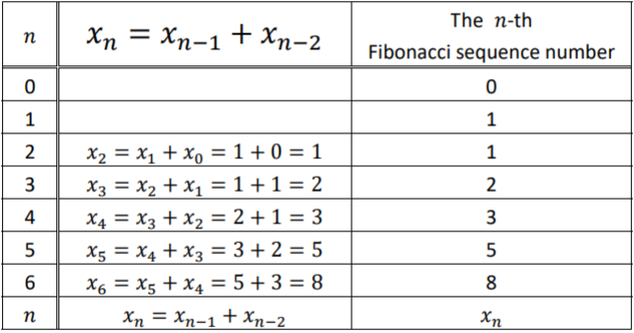

**Sample Input and Output**

